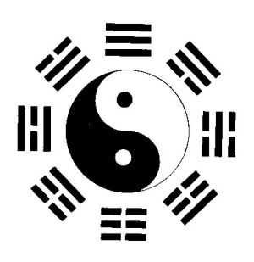
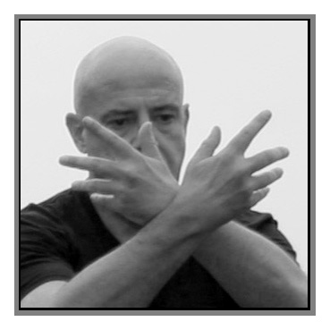
Shiyong Tai Chi
for health and relaxation

Starting in January at Privett Village Hall
Mondays, 7pm – 8pm

Tai Chi developed as an ‘internal art’ in ancient China.
It’s now practiced as a gentle form of ‘mind-body’ exercise,
to improve health by offering many benefits, including:

- Reducing stress through deep relaxation
- Increasing self-awareness and clearer thinking
- Improving mood and sense of wellbeing
- Improving posture, balance and co-ordination
- Ideal for people with controlled medical conditions

‘Shiyong Tai Chi’ is a practical approach and method of learning that’s simple, relevant and useful in daily life.

8-WEEK COURSE
STARTING IN JANUARY, 7pm-8pm
COURSE FEE: £40 (payable in advance)

PLEASE NOTE: A minimum number of advance bookings
will be required for the course to run.

For further information or to book a place, contact:
GARETH - 077 907 93859

e-mail: shiyongtaichi@yahoo.co.uk
website: www.qifitness.co.uk

